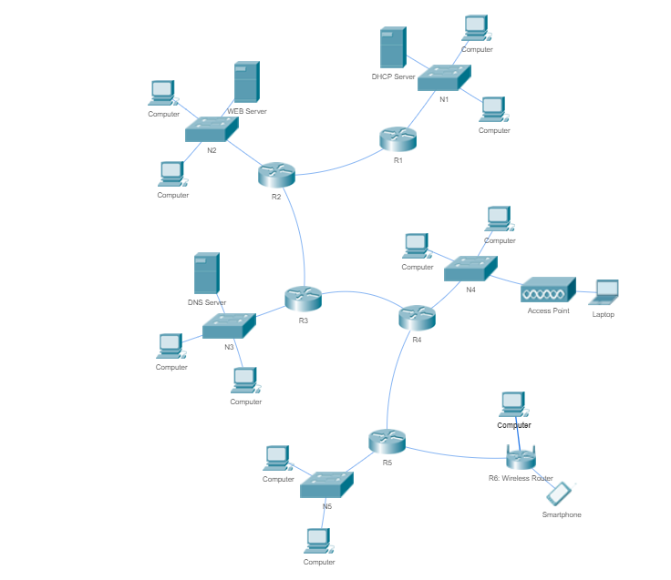

IP address: 13.93.203.0, NetMask: 255.255.255.0 /24

N1: 48

N2: 40

N3: 20

N4: 16

N5: 4

N12:2, N23:2, N34:2, N45:2, N5w:2

=> N1: 48+3 = 51 < 64 = 2^6 /26

N2: 40+3 = 43 < 64 = 2^6 /26

N3: 20+3 = 23 < 32 = 2^5 /27

N4: 16+3 =19 < 32 = 2^5 /27

N5: 4+3 = 7 < 8 = 2^3 /29

N12: 2+2 = 4< 4 = 2^2 /30

N23: 2+2 = 4< 4 = 2^2 /30

N34: 2+2 = 4< 4 = 2^2 /30

N45: 2+2 = 4< 4 = 2^2 /30

N5w: 2+2 = 4< 4 = 2^2 /30

64+64+32+32+8+4+4+4+4+4=220 < 2^8=256

[0-63][64-127][128-159][160-191][192-199][200-203][204-207][208-211][212-215][216-219][220-256]

N1 n2 n3 n4 n5 n12 n23 n34 n45 n5w

N1: 13.93.203.0 /26: R1=.1, Sdhcp=.2, NM: .192

N2: 13.93.203.64 /26, R2=.65, S2web=.66, NM: .192

N3: 13.93.203.128 /27, R3=.129, S3dns=.130, NM: .224

N4: 13.93.203.160 /27, R4=.161, NM: .224

N5: 13.93.203.192 /29, R5=.193, NM: .248

N12: 13.93.203.200 /30, R1=.201, R2=.202, NM: .252

N23: 13.93.203.204 /30, R2=.205, R3=.206, NM: .252

N34: 13.93.203.208 /30, R3=.209, R4=.210, NM: .252

N45: 13.93.203.212 /30, R4=.213, R5=.214, NM: .252

N5w: 13.93.203.216 /30, R5=.217, Rw=.218, NM: .252